**Mighty Ape Online Shopping**

Task A-1:

Once the user has found what they are looking for or their desired item they must first add it too there trolley. Once you have added it to your trolled and you wish to pay for just that item (note you can add more than one item or multiples of one item) you can proceed with the checkout. Mighty Ape will then prompt you with a login screen where it will ask you if you are a returning customer or a new customer. If you are a returning customer you must login with your username and password, if you are a new customer it will ask you to fill out a form of contact details then delivery details. After logging in as a returning customer it will give you an overview of your trolley this is to double check that you are about to order the right thing. The next step as a returning customer it will check if the address you’re wanting the items to be sent to is still the same if not there is an option to add a new address and once you have chosen your address you can proceed to the next step. The next screen will be shown for both pathways of new customer or returning customer which will be delivery options e.g. if you would like it to be able to be delivered on a Saturday (additional fee, or if you would like to sign for the package so it’s not left unattended). The last screen I was able to get to was the input of bank credentials, but after this step will most likely been place order and it will send the order out.

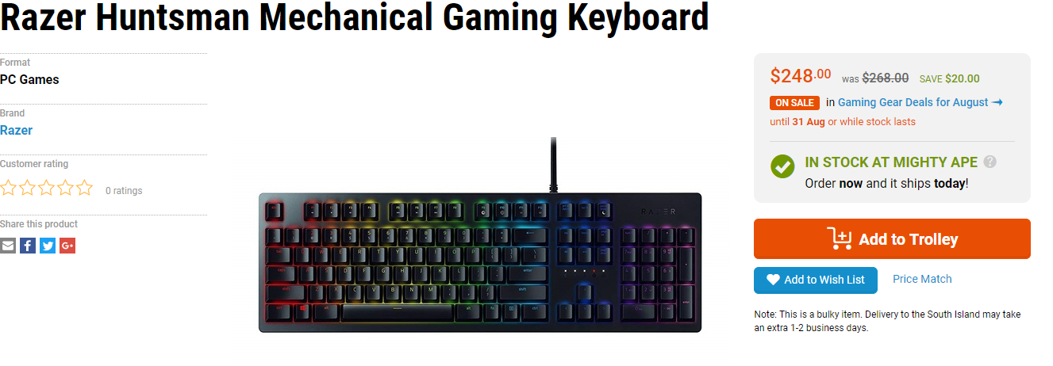

(Shopping, 2018)

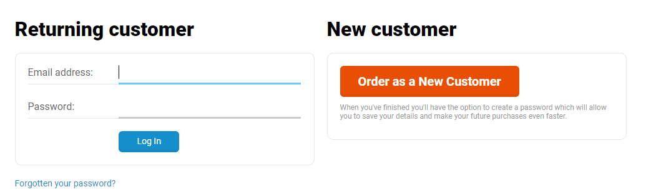

(Checkout, 2018)

